General Introduction :

The idea of human machine interaction led to research in Speech recognition. Automatic speech recognition uses the process and related technology for converting speech signals into a sequence of words or other linguistic units by means of an algorithm implemented as a computer program. Speech understanding systems presently are capable of understanding speech input for vocabularies of thousands of words in operational environments. Speech signal conveys two important types of information: (a) speech content and (b) The speaker identity. Speech recognizers aim to extract the lexical information from the speech signal independently of the speaker by reducing the inter-speaker variability. Speaker recognition is concerned with extracting the identity of the person. [1]
speech recognition concerns the study of signals of a spoken language where an analysis using the feature extraction method is used to produce a sequence of words. In short, this field attempts to develop machines that mimic human speech communication capabilities. There are several approaches to automatic speech recognition, namely acoustic phonetic, statistical pattern recognition and artificial intelligence approaches.[2]

In speech applications such as dictation software, the application's response to hearing a recognized word may be to write it in a word processor. In an interactive voice response system, the speech application might recognize a person's name and route a caller to that person's phone.Speech recognition is also different from voice recognition, though many people use the terms interchangeably. In a technical sense, voice recognition is strictly about trying to recognize individual voices, not what the speaker said. It is a form of biometrics, the process of identifying a specific individual, often used for security applications.
Because we all have distinct speaking styles — this is why you can tell your mom's voice from your favorite radio talk show host's — computers can take a sample of speech and analyze it for distinct characteristics, creating a "voice print" that is unique to an individual in the same way a fingerprint is. A common voice recognition system might make the user speak a password. It would then compare the speaker's voice print to a stored voice print and authenticate the user if they matched.
Though speech recognition uses some of the same fundamental technology as voice recognition, it is different because it does not try to identify individuals. Rather it tries to recognize what individuals say. It's the difference between knowing who is speaking and what is said. We are currently more concerned about what is said than who is. Coming to object recognition systems,
Object recognition and pattern analysis is one of the active research topics in
digital image processing. The technology is leaping into so much advancement that image recognition will become part and parcel of our daily lives. Applications such as Ultra sound, MRI use image processing to detect broken bones, tissues, Tumors and various kind of diseases and are used for various other industrial applications Contemporary it is used for detecting airport luggage scanning and for detecting the quality of food grains
to detect fungi and other micro diseases.. So now in modern era image processing is used for security reasons through thumb print recognition, eye retina detection and then for crime detection it is also used for face recognition.[2]
satellite imagery is used to detect crop growing patterns, their cultivated area, advance warning to farmers in Australia is given for pesticide and disease. One of the state of the art applications is the cruise missile guidance system developed by US Defense to Map the territory for possible accurate target selection by using GIS and image processing.
Even in Pakistan Sugar mills are using satellite imagery for planning their sugar can purchasing campaign and procurement planning. Imaging for medical reasons CT- Scan, MRI and Ultra Sound is now a days a common content in the patients medical history, detection of fungi is good topic to research. Researchers have put lot of eort in image processing.
For this project, we used Otsu's method and ood ll algorithm for segmenting and separating objects in image. Then we used HOG for feature extraction and SVM classifier for training and testing.

Objectives:
1. To recognize 4 different words through automatic speech recognition and convert to 3 digit binary word.
2. Based on the 3 digit binary word, A Image Recognition system to be developed to recognize the object pertaining to the command given.
Literary Survey :
Peeling and Moore (1987) [3] applied MLPs to digit recognition with excellent results. They used a static input buffer of 60 frames (1.2 seconds) of spectral coefficients, long enough for the longest spoken word; briefer words were padded with zeros and positioned randomly in the 60-frame buffer. Evaluating a variety of MLP topologies, they obtained the best performance
with a single hidden layer with 50 units. This network achieved accuracy near
that of an advanced HMM system: error rates were 0.25% versus 0.2% in speaker-dependent experiments, or 1.9% versus 0.6% for multi-speaker experiments, using a 40-speaker database of digits from RSRE. In addition, the MLP was typically five times faster than theHMM system.

Kammerer and Kupper (1988) [4] applied a variety of networks to the TI 20-word database, finding that a single-layer perceptron outperformed both multi-layer perceptrons and a DTW template-based recognizer in many cases. They used a static input buffer of 16 frames, into which each word was linearly normalized, with 16 2-bit coefficients per frame; performance
improved slightly when the training data was augmented by temporally distorted tokens. Error rates for the SLP versus DTW were 0.4% versus 0.7% in speaker-dependent experiments, or 2.7% versus 2.5% for speaker-independent experiments.

Lippmann (1989) [5] points out that while the above results seem impressive, they are mitigated by evidence that these small-vocabulary tasks are not really very difficult. Burton et al (1985) demonstrated that a simple recognizer based on whole-word vector quantization, without time alignment, can achieve speaker-dependent error rates as low as 0.8% for the TI
20-word database, or 0.3 for digits. Thus it is not surprising that simple networks can achieve good results on these tasks, in which temporal information is not very important.

Burr (1988) [6] applied MLPs to the more difficult task of alphabet recognition. He used a static input buffer of 20 frames, into which each spoken letter was linearly normalized, with 8 spectral coefficients per frame. Training on three sets of the 26 spoken letters and testing on a fourth set, an MLP achieved an error rate of 15% in speaker-dependent experiments, matching the accuracy of a DTW template-based approach.

Papageorgiou et al describe a pedestrian detector based on a polynomial SVM us- ing rectifed Haar wavelets as input descriptors, with a parts (subwindow) based variant in [10]m.
Depoortere et al gave an optimized version of this [11].
Gavrila Philomen take a more direct approach, extracting edge images and matching them to a set of learned exemplars using chamfer distance. This has been used in a practical real-time pedestrian detection system [12].
Viola et al [13] build an efficient moving person detector,using AdaBoost to train a chain of progressively more complex region rejection rules based on Haar-like wavelets and space-time differences.
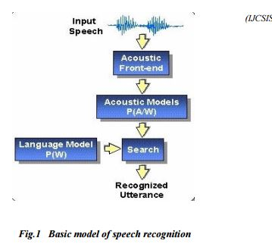
Ronfard et al build an articulated body detector by incorporating SVM based limb classifiers over 1st and 2nd order Gaussian filters in a dynamic programming frame work similar to those of Felzenszw alb Huttenlocher and Iof fe Forsyth[14].

Procedure :

Speech recognition systems can be separated in several different classes by describing what types of utterances they have the ability to recognize. These classes are classified as the following: Isolated Words, Connected Words, Continuous Speech, Spontaneous Speech. In this project we work on Isolated words since our objective here is to recognize only 4 words that are isolated from each other. After figuring out what word have spoken, we then find the position of the object pertaining to the command given through speech in an image taken through real time. Object recognition is a process for identifying a specic object in a digital image or video. Object recognition algorithms rely on matching, learning, or pattern recognition algorithms using appearance-based or feature-based techniques. Common techniques include edges, gradients, Histogram of Oriented Gradients (HOG), Haar wavelets, and
linear binary patterns. Object recognition is useful in applications such as video stabilization, automated vehicle parking systems, and cell counting in bio-imaging.

Isolated Words: Isolated word recognizers usually require each utterance to have quiet (lack of an audio signal) on both sides of the sample window. It accepts single words or single utterance at a time. These systems have "Listen/Not-Listen" states, where they require the speaker to wait between utterances (usually doing processing during the pauses). Isolated Utterance might be a better name for this class.

Approaches to speech recognition: Basically there exist three approaches to speech recognition. They are
a)Acoustic Phonetic Approach
b)Pattern Recognition Approach
c)Artificial Intelligence Approach.
The pattern-matching approach [8] involves two essential steps namely, pattern training and pattern comparison. We use Neural Networks as a tool here to perform both the steps.
Recognizers generally use a similar process to figure out what a speaker said:
1.The Automatic Speaker Recognition(ASR) loads a list of words to be recognized. This list of words is called a grammar.
2.The ASR loads audio from the speaker. This audio is represented as a waveform, essentially the mathematical representation of sound.
3.The ASR compares the waveform to its own acoustic models. These are databases that contain information about the waveforms of individual sounds and are what allow the engine to recognize speech.
4.The ASR compares the words in the grammar to the results it obtained from searching its acoustic models.
5.It then determines which words in the grammar the audio most closely matches and returns a result.
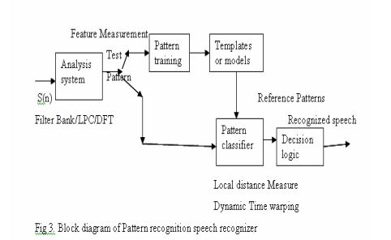

In the pattern-comparison stage of the approach, a direct comparison is made between the unknown speeches (the speech to be recognized) with each possible pattern learned in the training stage in order to determine the identity of the unknown according to the goodness of match of the patterns. The pattern-matching approach has become the predominant method for speech recognition in the last six decades. A block schematic diagram of pattern recognition is presented in fig.2. In this, there exists two methods namely template approach and stochastic approach.
Template based approach [9] to speech recognition have provided a family of techniques that have advanced the field considerably during the last six decades. The underlying idea is simple. A collection of prototypical speech patterns are stored as reference patterns representing the dictionary of candidate s words. Recognition is then carried out by matching an unknown spoken utterance with each of these reference templates and selecting the category of the best matching pattern. Usually templates for entire words are constructed. This has the advantage that, errors due to segmentation or classification of smaller acoustically more variable units such as phonemes can be avoided. Neural Networks are used as a tool for template approach. The other approach is Stochastic Approach where we use Hidden Markov Model.
Existing techniques for speech recognition have been represented diagrammatically in the following figure 3.

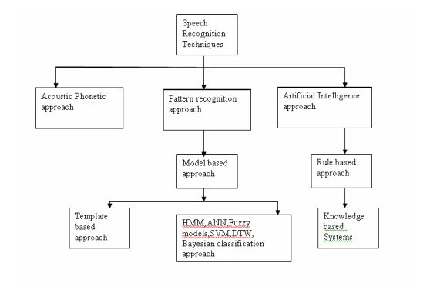
Feature Extraction of speech :

In speech recognition, the main goal of the feature extraction step is to compute a parsimonious sequence of feature vectors providing a compact representation of the given input signal. The feature extraction is usually performed in three stages. The first stage is called the speech analysis or the acoustic front end. It performs some kind of spectro temporal analysis of the signal and generates raw features describing the envelope of the power spectrum of short speech intervals. The second stage compiles an extended feature vector composed of static and dynamic features. Finally, the last stage( which is not always present) transforms these extended feature vectors into more compact and robust vectors that are then supplied to the recognizer. Although there is no real consensus as to what the optimal feature sets should look like, one usually would like them to have the following properties: they should allow an automatic system to discriminate between different through similar sounding speech sounds, they should allow for the automatic creation of acoustic models for these sounds without the need for an excessive amount of training data, and they should exhibit statistics which are largely invariant across speakers and speaking environment. There are many feature extraction methods in speech recognition. The following table lists some of them.
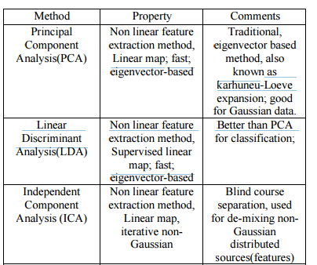

From the list of Feature extraction methods we use LDA method as it has more advantages over others and is suitable for our application. Which is then applied to Multilayer Perceptron(MLP) neural network for classification.

Now, after figuring out what word have spoken, we then find the position of the object pertaining to the command given through speech in an image taken through real time.

Approaches for object recognition:
It is basically done by two methods
1.Correlation Method
2.Supervised Learning Method

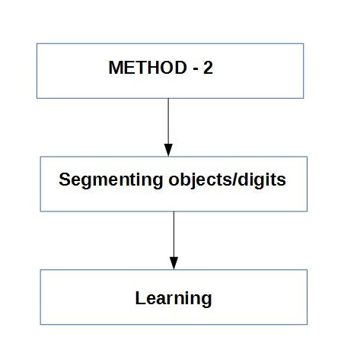

In Correlation method, the acquired image in real time is taken and starting from the top-left corner the required object prototype image(window) is correlated with the acquired image to right bottom. The location where we get maximum correlation coefficient is said be the location where the required object is found. But by the above lines we can say that it is time consuming and takes to much calculations. Hence we adopt Learning method.
In Learning method, We segment the image and then separate out each object from the image along with the coordinates of the location of the object. Then these individual objects(test images) are then passed to extract features and detect the object using classifier.

Otsu's Segmentation :

In computer vision and image processing, Otsu's method, named after Nobuyuki Otsu, is used to automatically perform clustering-based image thresholding, or, the reduction of a gray level image to a binary image. The algorithm assumes that the image contains two classes of pixels following bi-modal histogram (foreground pixels and background pixels), it then calculates the optimum threshold separating the two classes so
that their combined spread (intraclass variance) is minimal, or equivalently (because the sum of pairwise squared distances is constant), so that their inter-class variance is maximal. Consequently, Otsu's method is roughly a one-dimensional, discrete analog of Fisher's Discriminant Analysis.
The extension of the original method to multi-level thresholding is referred to as the Multi Otsu method.Equations are given below :
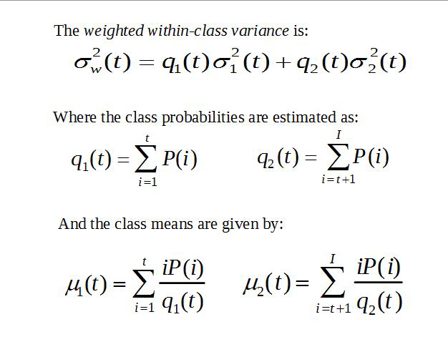
We show you a test image taken in a room before and after Otsu's Segmenta-
tion.
After Otsu's Segmentation we pass the image to ood ll algorithm to separate out each object based on minimum object size. An object(digit 3) is shown after passing through food fill algorithm in fig 2.4.

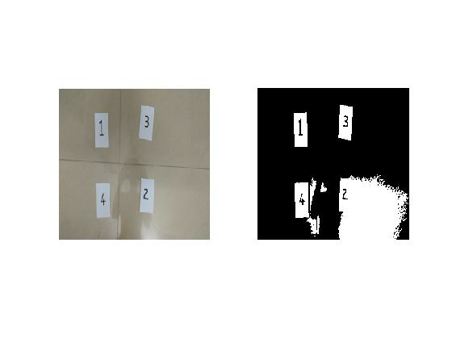

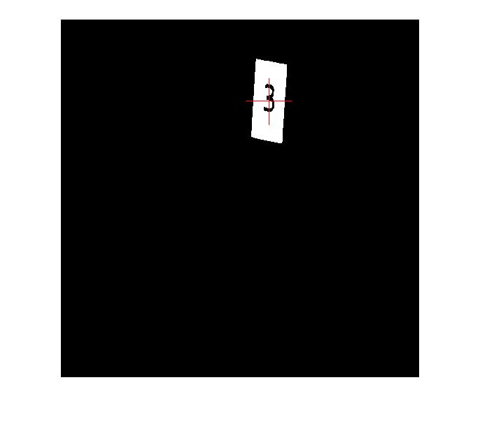
Feature Extraction of images :

After extracting each object from image we pass them through another step to
extract features of each object. Histogram of Oriented Gradient descriptors, or HOG descriptors, are feature descriptors used in computer vision and image processing for the purpose of object detection. The technique counts occurrences of gradient orientation in localized portions of an image.

The essential thought behind the Histogram of Oriented Gradient descriptors is that local object appearance and shape within an image can be described by the distribution of intensity gradients or edge directions. The implementation of these descriptors can be achieved by dividing the image in to small connected regions called cells, and for each cell compiling a histogram of gradient directions or edge orientations for the pixels within the cell. The combination of these histograms then represents the descriptor.

The following image shows the histogram visualisation applied to the above extracted 'digit 3' object.

Future Scope :

There are copious future applications for speech recognition. The output evaluated after speech recognition are used in various programs and applications to make physical interaction less systems. One such future application is our second objective where we use the O/P we got in first objective to be given to image recognition system where it recognizes the object placed in front of it based on the command given.
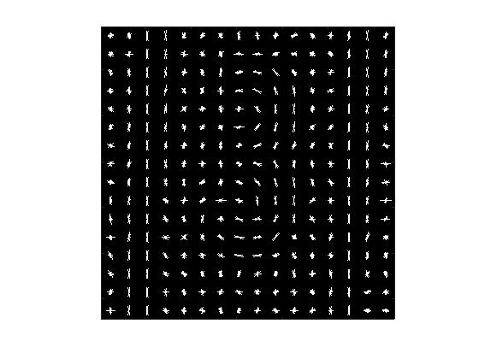

References :

1. Suma Swamy and K.V Ramakrishnan,AN EFFICIENT SPEECH RECOGNITION SYSTEM ,An International Journal (CSEIJ), Vol. 3, No. 4, August 2013
2. Bassam A.Q.Al-Qatab and Raja.N.Aninon, “Arabic Speech Recognition using Hidden Markov Model ToolKit (HTK)”, IEEE Information Technology (ITSim), 2010,page 557-562.
3. S.M. Peeling, R.K. Moore, Isolated digit recognition experiments using the multi-layer perceptron.1987
4. Bernhard R. Kämmerer, Wolfgang A. Küpper Experiments for isolated-word recognition with single- and two-layer perceptrons 1988
5.Richard P Lippmann, Review of Neural Networks for Speech Recognition, 1989
6.Burr, D.J., "Experiments on neural net recognition of spoken and written text," in Acoustics, Speech and Signal Processing, IEEE Transactions on , vol.36, no.7, pp.1162-1168, Jul 1988.
7. M.A.Anusuya ,S.K.Katti , "Speech recognition by machine: A review," in Proceedings of the IEEE , vol.64, no.4, pp.501-531, April 2009.
8.Rabiner & Juang - Fundamentals of Speech Recognition 1993
9.R.K.Moore, Twenty things we still don t know about speech , Proc.CRIM/ FORWISS Workshop on Progress and Prospects of speech Research an Technology , 1994.

